**Rachel Betz**

**Portfolio Part I**

**Developing a Reading Response**

**Kathleen Wells-Goodwin**

**5500-286: 002**

**November 3, 2012**

**Fictional Picture Book: How Mountains Are Made by Kathleen Weidner Zoehfeld**

1. The story starts off with a small group of children going on a hike on a nearby mountain. When they get to the top of the mountain, they find a fossil of a sea shell. The children wonder how the fossil got to the top of their mountain. They start discussing the idea of Plate Tectonics and how the plates move, causing different types of mountains. They talk about their fossil once being a living animal that died and sank to the bottom of the ocean. Then, over many years, the ocean floor was pushed up by magma pockets, forming mountains, and years of erosion allowed for the kids to see the fossil.
2. The book has a fictional story line and shows the children pushing and pulling on the Earth to form mountains. This may be fictional but much of the concepts and key words are fact. The book covers all four types of plate boundaries and even gives them an easy experiment they can try at home to better visualize mountain formation. This book would be great for my students with special needs or for those with a reading level far below that of my classroom textbook. The children could read this as an alternative to the text or an introduction to the topic before reading the text to scaffold their reading.
3. In response to this reading, I would have my students create their own story about how a land formation was formed. I would encourage them to pick a real formation such as Hawaii or Mount Everest. I would ask them to include vocabulary words and key concepts from the unit. They would also need a glossary and reference page.
4. Research to Build and Present Knowledge

8. Gather relevant information from multiple print and digital sources, using search terms effectively; assess the credibility and accuracy of each source; and quote or paraphrase the data and conclusions of others while avoiding plagiarism and following a standard format for citation.

1. Example of response:

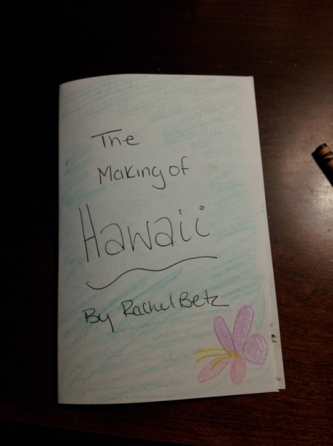 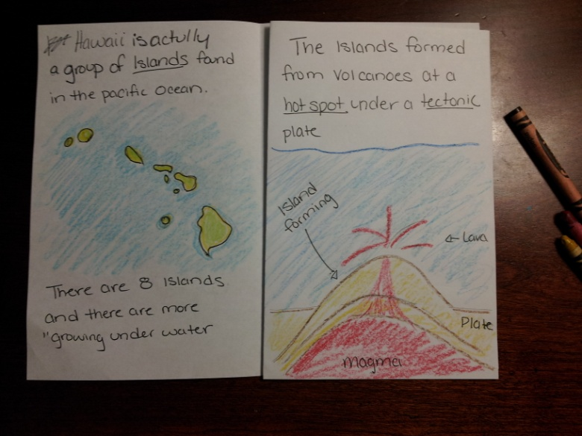

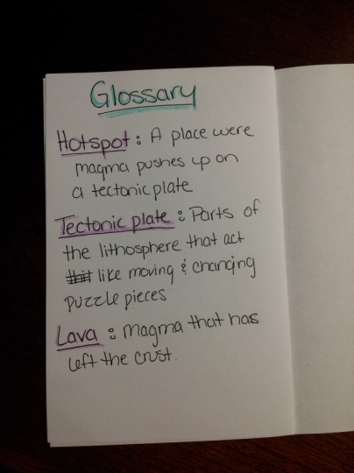

1. Zoehfeld, K.W. (1995). *How Mountains are Made*. New York, NY: HarperCollins.

**Poetry Book with Pictures: Where Fish Go in the Winter by Amy Goldman Koss**

1. This book is a level three for ages 6-9 which children should be able to read on their own. The book contains 14 short poems along with illustrations helping to explain the mysteries of science about topics such as "where to fish go in the winter" to, "why do onions make us cry?" This book gives scientific reason to children using easy to read words and understandable material.
2. I chose this book because it is a personal favorite. I like the idea that kids can figure out information in a fun and easy way versus reading a long and complex textbook. It is also easier to remember a short poem versus remembering a large quantity of text.
3. I would use this book in my middle school classroom even though it is below their level to show them how easy it is to make a poem about a topic. Furthermore, I like this book because I can use it with any topic, content, or lesson. I would have my students choose a vocabulary word from the unit or chapter they are learning and have them write a poem. I might give them the choice of word or the choice of poem type such as definition poems, cinquains, diamond poems, or acrostic poems, or even a haiku, depending on the lesson. I would also have them to illustrate their poem. I would then hang them up around the room. I also observed a teacher who took her students illustrations and projects like this and turned it into a handout for all of her students, so that they each had a copy.
4. **Range of Writing**

10. Write routinely over extended time frames (time for research, reflection, and revision) and shorter time frames (a single sitting or a day or two) for a range of discipline-specific tasks, purposes, and audiences

1. My example of a science poem is a Haiku comparing the Sun and the Moon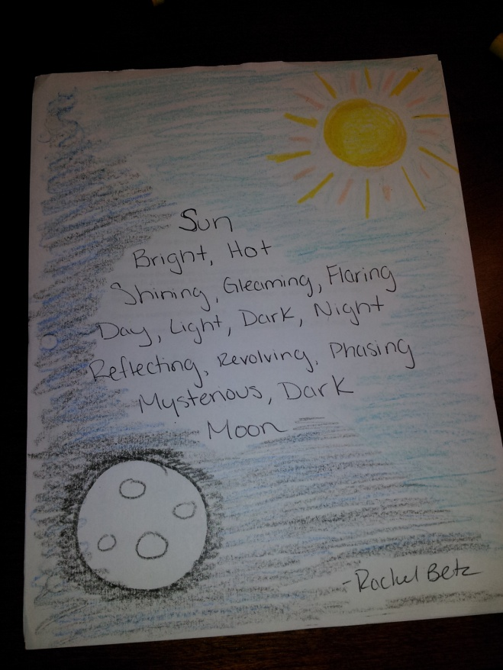
2. Koss, A.G. (1987). *Where Fish Go in Winter and Other Great Mysteries*. New York, NY: Puffin Books.

**Fiction Book: Amelia's Science Fair Disaster**

1. This book is about Amelia and her struggles in working in a group for the Science Fair. One of the group members turns out to be someone she cannot trust. The book is set up like a journal. The journal has information like a class schedule and conversion tables at the end. The book is a fun story with some real science mixed in.
2. I chose this book because it is light hearted and fun but talks about important issues in a classroom such as team or Group projects. Group projects have their down side but they also build social skills and teamwork. The best way to make sure group projects don’t get out of hand is to individually grade the students. The book also talks about real science experiments that students could get ideas for their own science fair project.
3. I would use this story to get the students thinking about journaling their own ideas about science. One of the important parts about science that they will see as they get older is Lab write ups. Scientists take detailed notes of their experiments to reference back to later. It is a good idea to get the students used to this idea early. For my response, I would have the students make their own lab journals using a composition notebook. That way all of their information is in one place, they can look back at it periodically, and it is easy to grade with the format. For every lab or project they do, I would have them do a write up/journal/reflection the followed the format below. I would add a page about team and self evaluation for group projects.



1. **Text Types and Purposes**

1. Write arguments to support claims with clear reasons and relevant evidence.

a. Introduce claim(s), acknowledge and distinguish the claim(s) from alternate or opposing claims, and organize the reasons and evidence logically.

b. Support claim(s) with logical reasoning and relevant evidence, using accurate, credible sources and demonstrating an understanding of the topic or text.

c. Use words, phrases, and clauses to create cohesion and clarify the relationships among claim(s), counterclaims, reasons, and evidence.

d. Establish and maintain a formal style.

e. Provide a concluding statement or section that follows from and supports the argument presented.

1. Example of response: 
2. Moss, M. (2008). *Amelia's Science Fair Disaster.* New York, NY: Simon & Schuster Books for Young Readers.

**Faction Graphic Novel: The Birth of the Earth by Jacqui Bailey**

1. This book follows the formation of our Earth from the Big Bang until life formed. The book explains the creation of our galaxy, and the birth of stars. The book talks about how everything that makes up our galaxy and the stars and planets with in it, were once just a swirling pile of dust and gas. The book also discusses ideas about what would happen if we were too close or too far away, we would not be here today if that happened. And do not forget about water! The book gives example of how our world would not be the same without water. Life would not exist on Earth without water, and the formations of our planet would not be the same either. I chose this book because of the genre. It is a cartoon history of the Earth, in other words, it is a comic book. I could see my students flipping through the book and seeing ideas in a new light and they would find this much more fun than reading the text book.
2. This book is a comic book, but it still has great features for a Science book and for an English book. On the first page there is a hand holding a sign. The sign explains that words that **look like this** have their definitions explained in the glossary found on page 30 and that asterisk (*) has a box near it explaining more about the topic or idea. The visuals are great and they have fun "sound" bubbles like "BANG!" and the planets sometimes talk and have conversations with other items. At the back of the book there is a page with information about other planets and how each planet compares in size to the Earth. And finally there is a glossary explaining all the key terms found in the book. For English there are metaphors, onamonapias, and other action words!
3. The book its self does not go into great detail about plate tectonics, just a few sentences. However, I could have my students get in groups and write their own comic books about a topic, key word, or section. Then the groups would copy their work and share it with the class so that they had their own comic books to understand plate tectonics. In the end, I could take the best owns and make a real book for the whole class, have it printed out and bound.
4. Production and Distribution of Writing

5. With some guidance and support from peers and adults, develop and strengthen writing as needed by planning, revising, editing, rewriting, or trying

a new approach, focusing on how well purpose and audience have been addressed. Editing for conventions should demonstrate command of Language standards 1–3 up to and including grade 8 on page 52.)

1. Example of Response: Plate Tectonics and Convergent Boundaries

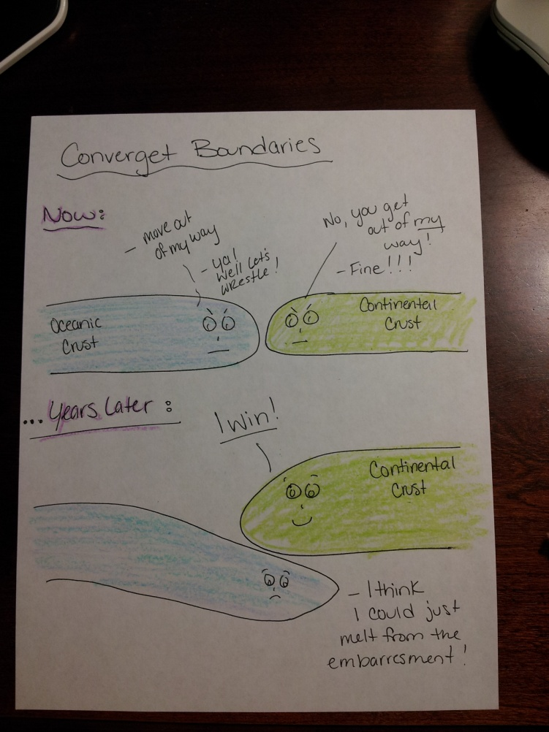

1. Bailey, J. (2001) *The Birth of the Earth*. Toronto: Kids Can Press.

**Non Fiction picture book: Rain Forest Secrets by Arthur Dorros**

1. This book introduces the secrets of the rain forest. The book explains key terms and ideas such as the levels of the plant growth. How the trees get their nutrients. It even talks about the people who live in the rainforest.
2. I chose this book for its great picture detail and how nicely the author writes an informational book with lower levels of text and easy to understand explanations. The author/illustrator builds in great diagrams, filled with information, into the pictures.
3. I would use this in a lower grade level to help them find facts and important information in books. I would have them first read the book, then as they re-read the book, , draw their own illustration to cover the main concept of the story and add in facts they found in the book.
4. Integration of Knowledge and Ideas

7. Analyze how visual and multimedia elements contribute to the meaning, tone, or beauty of a text (e.g., graphic novel, multimedia presentation of fiction, folktale, myth, poem).

1. Example of response:

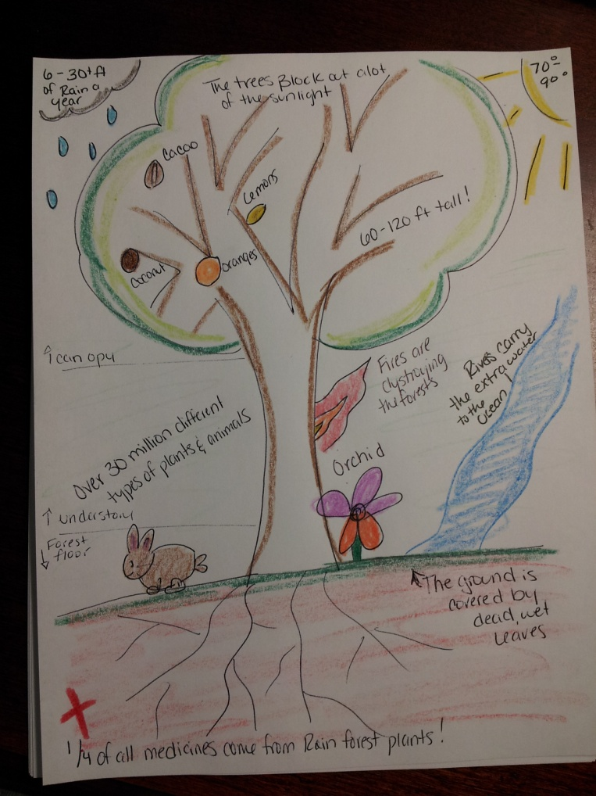

1. Dorros, A. (1990). *Rain Forest Secrets*. New York, NY: Scholastic Books.

**Portfolio Part II**

**Developing a Reading Response**

**Kathleen Wells-Goodwin**

**5500-286: 002**

**November 3, 2012**

**Historical Fiction: *The Invention of Hugo Cabret* by Brian Sleznick**

1. *The Invention of Hugo Cabret* is a book about a small boy who is all alone. His father is dead and his mean Uncle left and never came back, leaving Hugo in charge of all the clocks in the train station. Hugo's only hope is to fix the automaton that his dad found at the museum, and staying hidden while he does so. Until one day when the toy shop owner catches him stealing and takes his father's notebook from him. Hugo must now work for the toy shop too, if he ever hopes to get back his notebook. While working at the toy shop, his life quickly changes. He meets a girl who unknowingly helps Hugo fix the automaton, finds the inventor of the automaton, discovers a once thought dead movie maker is still alive, brings the spark back to the life of an old man, and finds a family.
2. The response for this story will be to create two journal responses from two different scenes from the book. Put yourself in the shoes of one of the characters.
3. This response is a great way to get students to use their critical thinking skills. We often take the side of the story teller, but what if we step into someone else's shoes? Teachers can have students introduce the idea of debates by using this response. Was it right for Hugo to take the key? Have the students pretend to be the characters, maybe even have them get in character and put them on trial.
4. Example of the response:

Journal #1 Page 234 from Isabella's perspective

Hugo had just run away with the notebook she had stolen for him. At the instance, she felt an emptiness around her neck. She moved her hand to her throat. Her necklace was gone! Hugo must have taken it! Quickly she scanned the area for him. When she found him, she ran after him, followed him into the walls of the station. Where was he going? How did he know how to move around in here? Isabella could not believe this was happening. She helped Hugo! She trusted him, and this is how he repaid her? She had to find him. Still she ran. When she caught up to him, he was in a room, if you could call it that. It was bare and cold, but there Hugo was. She lunged for him. She HAD to get that necklace back. She would get in trouble if she lost it. She would have to admit that she took the necklace in the first place! She did not want to do that. She couldn’t let down the people who had taken her in, loved her when she had no one else. Angrily she yelled at him! "You stole my key!"

** This entry is rewriting the story from the other characters perspective. It takes into account their ideas and feeling**

Journal # 2 Page 392 from Georges Melies perspective

Today way an extraordinary day. I feel like a new man, like I am reborn. It started when I was awoken from my nap. Getting up to yell at Isabella, I opened my door to hear the noise of a film projector. Why would that be in my house? They knew I forbid anything to do with movies in my home; I did not want the horrible reminder of my past. I hastily made it into the room. I did not even notice the crowd of people, just the movie, and my movie! I was surprised. I thought they had all been destroyed. Years of pent up emotions left me that instance. I took the film and ran back to my room. There was more, I had kept more! I had seen where the kids had hidden it. I locked the door, these were my memories, my films and I had to relive them. I broke the armoire open and found the pictures I had once drawn. I was instantly taken back in time. The joy that I had blocked for so many years came flooding back into me, bringing me new life!

** This is a diary like journal in the perspective of George, as if he is looking back and retelling that moment.**

**Realistic Fiction: by Jacqueline Woodson**

1. *If You Come Softly* is a story about two young teens. Both Jeremiah and Ellie are new at Percy Academy. The two meet and it is love at first sight. But racism gets in the way of their love. They hide that they are together but in the end, fate takes Jeremiah away from Ellie and she has to deal with the loss.
2. The response for this story is to Select a poetic form (any kind) and write a poem in response to the story. Then set up a two-column journal page labeled "what they said" and "what I think". Make at least five entries and state which part of the book they came from.
3. Poetry is a great way to get students to express their own feelings about the story or the stories theme. A teacher can have them pick the topic or poem type or pick from the students. The journal helps them to keep up with the story and stop/pause to reflect on what is happening.
4. Example of response:

**Love and Differences**

Love

Consuming, Captivating

Is always changing

No two are alike

Would we want it that way?

Boring, bland

Never changing?

Diversity, Difference

In love and in Life

Journal

|  |  |
| --- | --- |
| What they said | What I think |
| "How long would it be like this? Two addresses. Two phone numbers. Two bedrooms." Page 34 | It must be hard to live like that. I am in college, going back and forth from school, work, home, friends, boyfriend, family and I don’t have much me time, I feel like I am always moving, lost in the shuffle, waiting for the next break to sit back and breath. |
| "I just think to have a boyfriend or girlfriend from a different race is really hard." Pg 57 | You would think her sister would understand that she didn’t choose to love him, to love a black man, but it happened, just like Anna fell in love with another girl instead of a boy. |
| "feels like I am spinning,… like the whole world is spinning" pg 112 | I know they are talking about leaves but it could also be about his life, like it is making a big change, |
| "he wanted to tell somebody-not the way he and his homeboys talked…not like that…whispering-how strange and perfect it was" pg 118 | It makes you think back to the time when you really know you love someone. You don’t what to share the silly stuff, the girl/guy talk, but to share how important that person is to you. How much better you life is because that person is there for you. |
| Remember what you can Elisha…remember what you can. Pg 2 | I went back to this because it sums up life and death. One day a person you love will die, maybe that someone already has, and as the days pass, you may forget their face, or their birthday, but you will always remember how they made you feel, the place in your heart where they once were, will always be there. Hidden and protected, but there. No one can take that away from you. You just have to be brave enough to face the memories for the good they have, not for the loss they remind you of. |

**Modern Fantasy: *Found* by Margaret Peterson Haddix**

1. *Found* is a book about a young boy named Jonah, his best friend Chip, and his little sister Katherine. Jonah grew up knowing that he was adopted but felt loved by his family, and never really questioned his past. But then one day, he gets a mysterious letter, and so does his new friend Chip. At first Jonah decides it is a joke, but as more and more letters show up, and they find out that Chip was also adopted, but never knew it, a mystery starts to unravel. The three of them start to investigate, even going to the FBI. But soon, the past catches up with them and the mystery is revealed, but how to deal with the truth?
2. The response for this story is to read the book and then after every few chapters, summarize what has happened and predict what might happen in the following chapters and why.
3. This response is a great way to get students to use their critical thinking skills. It also allows them to stop and think about what they have read and what it might mean. This would be good if the students were reading the book in sections, not just in one sitting as they could go back and review what had happened before progressing.
4. Example of the response:

**Chapter 12**

**Summary:**

Jonah and Katherine just got home from the FBI and go to Chip’s house to look at the photos Katherine took. They have a list of Witnesses, and a list of Survivors. Jonah and Chip are on that list.

**Made Predictions:**

The boys survived some kind of accident that was covered up by the government. The government is trying to find the truth. Maybe the people sending the letters are trying to get the truth out or are trying to warn them that the people the government are finding them from has found them.

**Questions:**

How come the boys live so close together, they are neighbors now, but Chip just moved there, it cannot be a coincidence?

What part is Katherine going to play in this?

What are the kinds being “protected” from?

Are the letters being sent from the good guys or the bad guys?